**RIPHAH INTERNATIONAL UNIVERSITY, ISLAMABAD**



**Lab 1**

**Bachelors of Computer science – 6th semester**

**Subject:** Artificial Intelligence Lab

**Submitted to:** Ma’am Ayesha

**Submitted by:** Munaza Malik

**Sap Id:** 44956

**Date:** 12th February, 2025

**Task 1:**

Write a python program to display your profile like: name, age address, phone no, email, age, cnic in different lines.

**Code:**

name= "Munaza"  
age=20  
address="DHA,Isb"  
phoneno=98765432134  
email="abc@gmail.com"  
cnic=3456798765439  
  
print(name)  
print(age)  
print(address)  
print(phoneno)  
print(email)  
print(cnic)

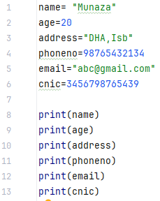

**Output:**

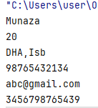

**Task 2:**

Write a python program that:

1. Takes sap id as input from the user
2. Takes name as input from the user
3. Shows an output
4. “hey ‘**name’** your sap is ‘**sap’**”

**Code:**

sapid=input("Enter your sapid:")  
name=input("Enter your name:")  
print(f"hey {name} your sapid is {sapid}")

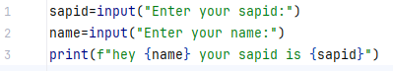

**Output:**

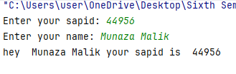

**Task 3:**

Write a python program to swap two variables.

**Code:**

var1=20  
var2=30  
print("Before Swapping:")  
print("variable 1: ", var1)  
print("variable 2: ", var2)  
  
temp=var1  
var1=var2  
var2=temp  
  
print("After Swapping:")  
print("variable 1: ", var1)  
print("variable 2: ", var2)

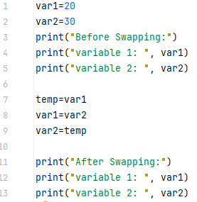\

**Output:**

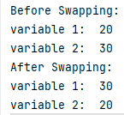

**Task 4:**

Message=” Programming language”, find r, a, m, n, u in this string.

**Code:**

message="programming language"  
  
print("index of 'r': ", message.find('r'))  
print("index of 'a': ", message.find('a'))  
print("index of 'm': ", message.find('m'))  
print("index of 'n': ", message.find('n'))  
print("index of 'u': ", message.find('u'))

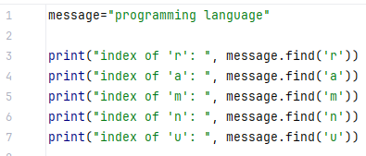

**Output:**

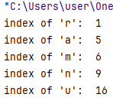

**Task 5:**

Take two variables and initialize them, apply comparison operators using print statement.no conditional statements allowed.

**Code:**

a=5  
b=6  
  
print("a is greater than b",a>b)  
print("a is less than b",a<b)  
print("a is equal to b",a==b)  
print("a is not equal to b",a!=b)  
print("a is greater than and equal to b",a>=b)  
print("a is less than and equal to b",a<=b)

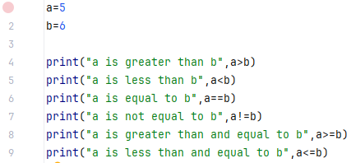

**Output:**

